CSCU9N5 REPORT INTRO TO ECLIPSE DESIGN DOCumentation

Stirling University

Student NUMBER: 2636161

Contents

1 Product description 2

1.1 Concept of website 2

1.2 Target audience 2

1.2.1 Persona 1 3

1.2.2 Persona 2 3

1.3 Delivery of information 3

2 Design 4

2.1 Design decisions 4

2.1.1 Website navigation 4

2.1.2 Colour Scheme 5

2.1.3 Fonts 6

2.14 Consistency 6

2.1.5 Audio 7

2.1.6 Buttons 7

2.1.7 Animations 7

2.1.8 Reducing short-term Memory Load 8

2.2 Navigation map 8

2.4 Wireframes 9

2.4.1 Home page wireframe 9

2.4.2 Tutorial pages 10

2.4.3 Installation guide 11

2.5 Scenarios 12

2.5.1 Scenario 1 12

2.5.2 Scenario 2 13

3 Prototype description 13

4 List of sources 14

4.1 JavaScript and CSS 14

4.2 Media 15

5 References 15

# 1 Product description

## 1.1 Concept of website

The product that I will be creating is a website called Intro to eclipse the main html file is called index.html. The purpose of the website is to create an easy way to introduce new users to the software package eclipse by helping them learn the basics of eclipse as well as offering help to more experienced users by offering some useful advice to more how to improve at using the software.

The content that will be included in the website will show the very basics of eclipse such as showing users how to install the software, how to create a workspace, creating projects and how to use the user interface of the software.

There will also be tutorials for the more advanced features offering tutorials to more experienced users such as generating getters and setter and refactoring their code.

The website will also contain tutorials on the basic fundamentals of Java programming with information about variables, functions if statements and loops.

The way that the tutorials will work is by creating step by step written guides on what the user has to do to achieve their goal. Each step in the tutorial will contain a written description of what they need to do and an image with an animation to further help highlight what the user needs to do.

For the more complex guides, I will provide a video guide to give the user an alternative way of following the tutorial. I feel that doing this would be helpful to users as it would allow the user to get a better idea of what they need to do if they are struggling to follow the steps that are in the written guides.

Another goal of the website is to create a stylish website that puts the functionality of the website over the way that it looks by creating a website that is easy for users to use and navigation as well as keeping to a consistent design throughout the whole website. I will be designing the website so that it can be easily accessed by users of any skill level of technology and to be accessible to users with disabilities.

## 1.2 Target audience

The main target audience of this website is people who are entirely new to using eclipse and are looking for advice on how to get started using the software. The website the age group that the website is targeted towards is users who are over 12

Another audience that the website targets are users who are more familiar with using eclipse but, are looking for advice that can help them improve their user experience when using the software.

To help me further identify who I am designing the website for I have created a few different personas that represent potential users of the website.

### 1.2.1 Persona 1

Andy is a 19-year-old male from Norway he is currently living in Scotland to study chemistry at Glasgow college. He has never studied computing and his knowledge of computers is fairly limited he mainly uses them to access the internet and gaming.

He has never done any programming before but has decided that he wants to learn Java as a hobby. He likes gaming, watching movies and playing the clarinet. He dislikes Running, hard-boiled eggs and instructions that are difficult to follow.

He has performed some research and has found that before starting programming he should install a development environment during his research, he found out about eclipse and is looking to find more information about eclipse. His goal is to learn the basic fundamentals of eclipse so that he can start programming.

### 1.2.2 Persona 2

Paul Is a 25-year-old from Scotland and is currently at Stirling university studying computing he has a lot of experience using computers and has good knowledge of programming.

He has been using a different development environment for the majority of the time that he has done computing. He likes programming, Space documentaries and football. He dislikes talk shows, horror movies and pineapple.

While he has used eclipse a few times and is somewhat familiar with the basics of eclipse he would like to learn some useful tips on how to use it better for a class that he is taking at university that requires him to use eclipse his goal is to be able to learn and use the shortcuts that eclipse offers.

## 1.3 Delivery of information

The way I will be delivering the website is via the internet hosted by a web server this will make the website available to a wide audience. The main way users will access the website on the internet is on a computer but will also be accessible to users on mobile.

The reason that users will access the website on their computer via the internet is due to the nature of eclipse I don’t feel that users would use the website if they didn’t have eclipse open on a computer.

Another way that the information can be delivered is by having the client receive a copy of the website file and hosting it locally on their computer the way that this could be done is to zip up the website then either by having emailing or giving the client a USB Stick with a copy of the website on it. Since the website is hosted locally the user doesn’t need a connection to the internet to be able to access the website.

# 2 Design

## 2.1 Design decisions

### 2.1.1 Website navigation

The main way users will be able to navigate the website is by using a simple horizontal multi-level that allows users to click on the page that they want to view.

When users hover over a link the button will be highlighted to indicate that the button can be clicked on sections of the menu that have a submenu when the user hovers over a link a drop-down menu will appear that contains the subsections of that page.

Using this type of menu system will also make it easy to expand the website with new pages as I will be able to simply add a new link in the menu which will resize the menu automatically keeping everything in the website consistent and since the menu is a function that will be called I will only have to add the new link into the function reducing the amount of time significantly that it would take to make the change.

Since the navigation map will be on each of the pages of the website, users will easily be able to reverse their actions as if they want to return to a previous page, they will be able to return to it from the navigation bar.

Another form of navigation the website will offer is to allow users to navigate to the different guides by having a set of buttons at the bottom of each page which will take users to the next or previous guide on the site this will be a linear form of navigation which will start from the most basic tutorial to the more complex parts of the site I feel that this will be a helpful way for users to use the website as it will give a form of guidance in what order they should use each of the tutorials.

### 2.1.2 Colour Scheme

One of the golden rules of design is to ensure that the website is accessible to users, therefore before deciding on the colour scheme that will be used, I performed some research about colour blindness to avoid colour combos that could affect those users. (Collinge, 2017)

The way that I will be using dark colours in the background and light colours for the text or using dark colours for text and light colours for the background, I will also be using colours that make the website accessible to users who are colour blind this will Ensure that all the information displayed by the website is easy for the user to read.

After performing this research, I have decided that I will be using a dark theme for the colour scheme of the website. I feel that this is a good design decision as I feel that it will give the website a good look whilst still being accessible to users which is the second golden rule. To help me further understand how to create the colour scheme properly performed some research on dark themes. (Material.io, 2019)

For the background of the website, I will be using a dark grey (#121212) and the font colour I will be using is white(#FFFFFF) I ran the colour scheme through a contrast checker to ensure that the font colour stands out enough to be readable to the user.

**Colour scheme contrast checker**

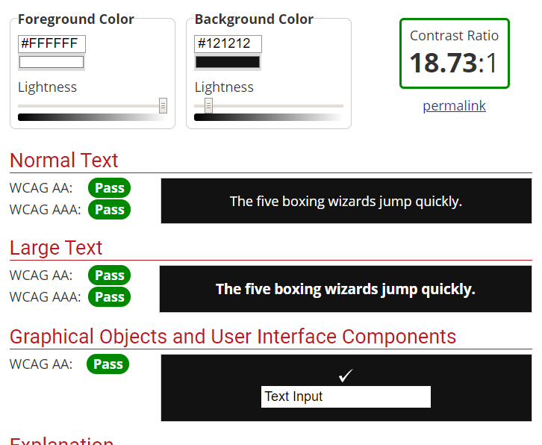

This shows that the font will stand out on the background colour making it easy for users to read.

For the buttons, I will be using a dark turquoise colour (#018786) and when the user hovers over the button I will be using a lighter turquoise(#03DAC6) I am doing this to further help users with using the website showing them that they can click the buttons.

The colour scheme that the navigation bar will use is a lighter grey (#333) and white for the font colour when a user hovers over a button in the menu the background colour will change to a grey colour and the font colour will change to light turquoise(#03DAC6) this will help users identify when they are hovering over a button in the menu and that they can click on it to change page.

A visual representation of the colours that will be used.

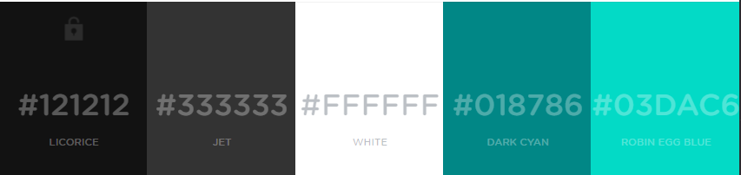

### 2.1.3 Fonts

I performed some research on what type of font I should use for the website (DVG, 2017) and decided that to improve the usability of the website I should use sans fonts that easily stand out to improve the readability of the website rather than using a serif font which may look good but may make the website more difficult to read.

The default font that I will be using is veranda and if that is not available to the user the website will use Arial and if the user doesn’t have that the website will use sans-serif. I feel this would help make the website more accessible.

### 2.14 Consistency

The first Schneiderman golden rule is to create a website that is consistent to ensure that the fonts and the colour scheme are consistent I will be using a CSS file which will be linked to each page in the website this will ensure that the colour scheme and fonts are consistent.

Another way that the website will be designed is that each page on the website will all follow a similar structure I will be creating div tags for all of the content areas on the website which will consistently be used on each page.

### 2.1.5 Audio

While I intend to use audio on the website it will be used sparingly so that it doesn’t annoy the user. One of Schneiderman’s golden rules Is to provide the user with feedback when using the website to help with this I will be using audio for when the user presses a button on the website to improve the responsive feel of the website.

An example of the way audio will be used is when the user clicks the hide/show buttons when the user clicks hide step it will play a sound and when they press the button again to show the information it will be a different sound.

### 2.1.6 Buttons

As mentioned in section (2.1.5) the website will use the audio to provide feedback to the user when they do something. Another way that feedback will be given to the user is when they hover over a button either in the content area of the page or in the navigation menu the colour of the button will change this will help indicate to the user that they are able to click the button.

### 2.1.7 Animations

Animations will be used to help users when they are doing the tutorials the main way that animation is on the images to help highlight what the user should be looking at.

While animations are useful to help draw the attention of the user, they can also be annoying therefore animations I will only be using animation If I feel they would be helpful to get information across to the user.

The way that the animations used in the guides will be triggered is when the user hovers over an image in the guide.

### 2.1.8 Reducing short-term Memory Load

This is rule eight for universal usability the rule means that the website should not force the user to remember a lot of information at once.

To achieve this goal the tutorials will only contain a small amount of information in each step and use an image to help guide the user. It is important to do this because the main goal is for the website to be as simple as possible for the user to follow.

## 2.2 Navigation map

To help show how the application is navigated I have created a navigation map this diagram will give an overview of the way users will be able to navigate the application showing what pages can be accessed in what parts of the application as well as showing any external pages that the user can go to.

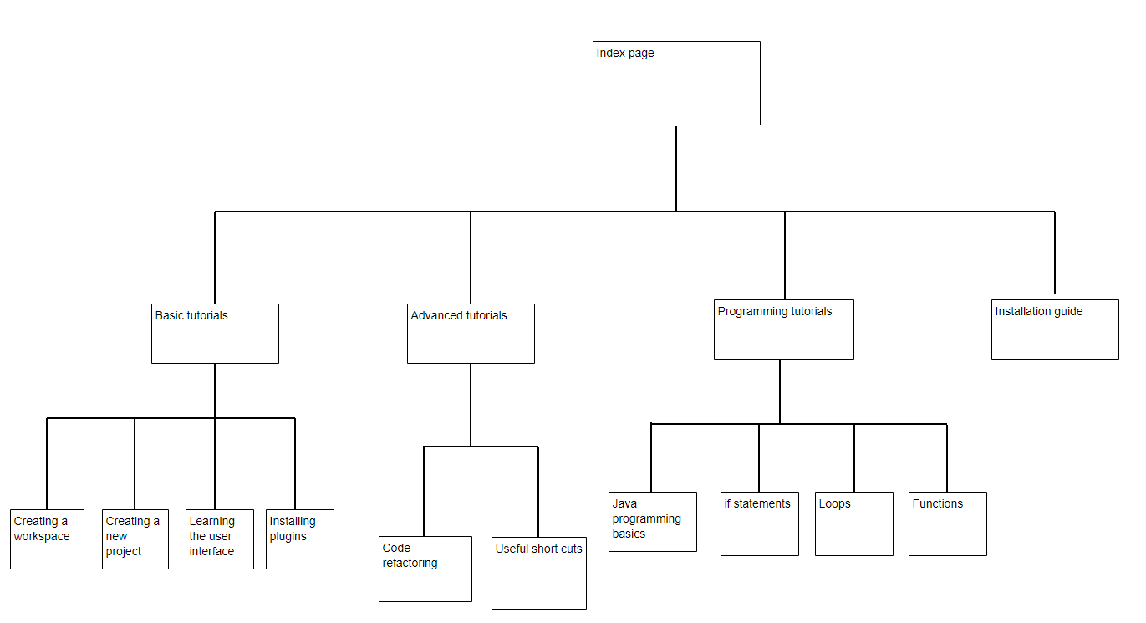The navigation map will also indicate any of the submenus in the navigation bar by having those pages extent off from the main part of the menu.

## 2.4 Wireframes

I have created some wireframes for the pages on the website the reason that I have created these is to get an idea of how the website will look doing this will save time when developing the website as I will have an idea of what the website will look like before building the site.

### 

### 2.4.1 Home page wireframe

This is the wireframe for the home page of the website it will be the first page users see when they open the website. I took into consideration what types of users would be using the website and have designed this page to give a good introduction to the target audience of the website which I decided in section (1.2).

The information in the introduction will include what the website offers and a description of the tutorials.

Considering new users may not fully understand the information from the introduction I have also included a slide show which has some images of different things users will learn during the tutorials.

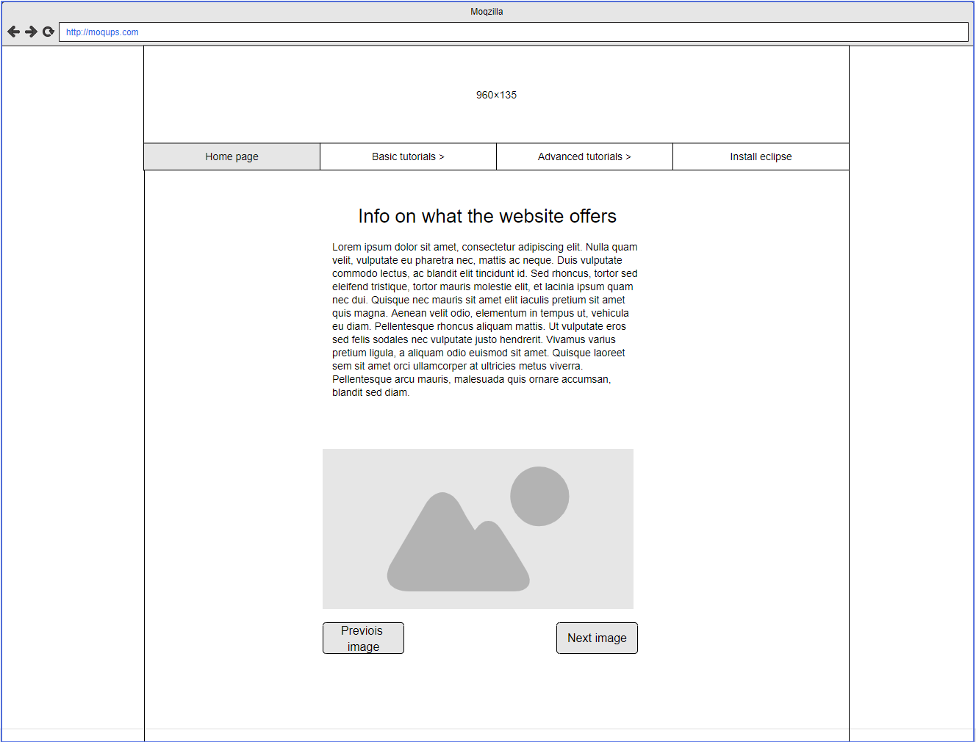

### 

### 2.4.2 Tutorial pages

The tutorial pages on the website will all follow a similar structure to ensure consistency with the written guides each step in the tutorial will contain a button to hide the step a description of what the user has to do to complete the step and image with an animation which will draw attention to the area that they should be looking to complete the step.

The tutorials will contain several steps depending on how many are needed to give the user enough guidance to be able to complete the tutorial. For the more complex tutorials they will also include a video guide along with the written tutorial it will be possible for the user to hide the video.

with the linear navigation method, the first guide in the tutorial section will only have the option to go to the next guide and the last tutorial will only have the option to go back to the previous guide. I am doing this rather than having the buttons always there to avoid confusion since the buttons wouldn’t do anything.

**Wireframe - Tutorial page with video guide**

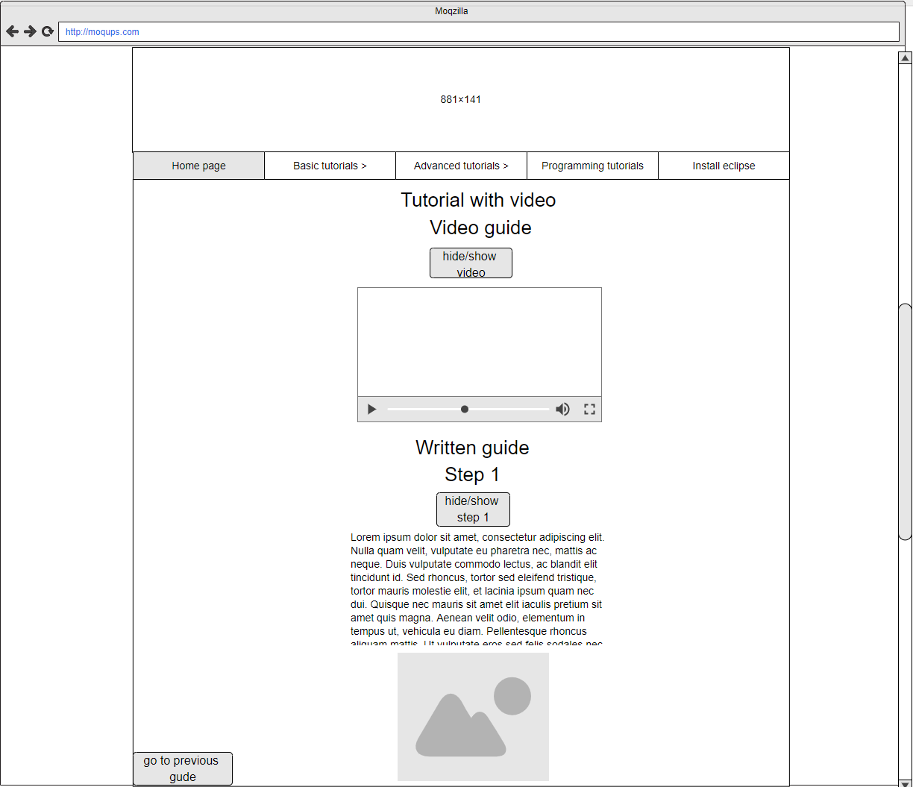

**Wireframe – tutorial without video guide**

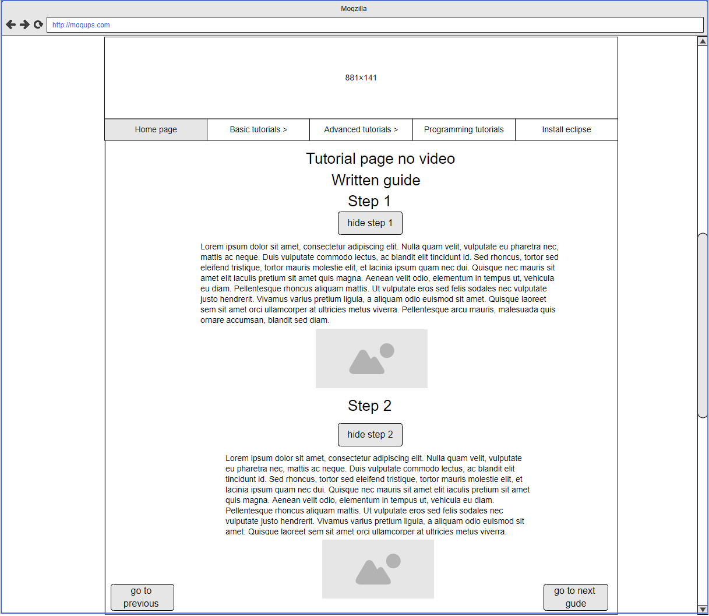

### 2.4.3 Installation guide

This wireframe shows the page that will contain the guide on how to install eclipse it will contain a link to the eclipse installation page and will give a step by step guide on how to install eclipse each step has the written instruction as well as an image on what to do.

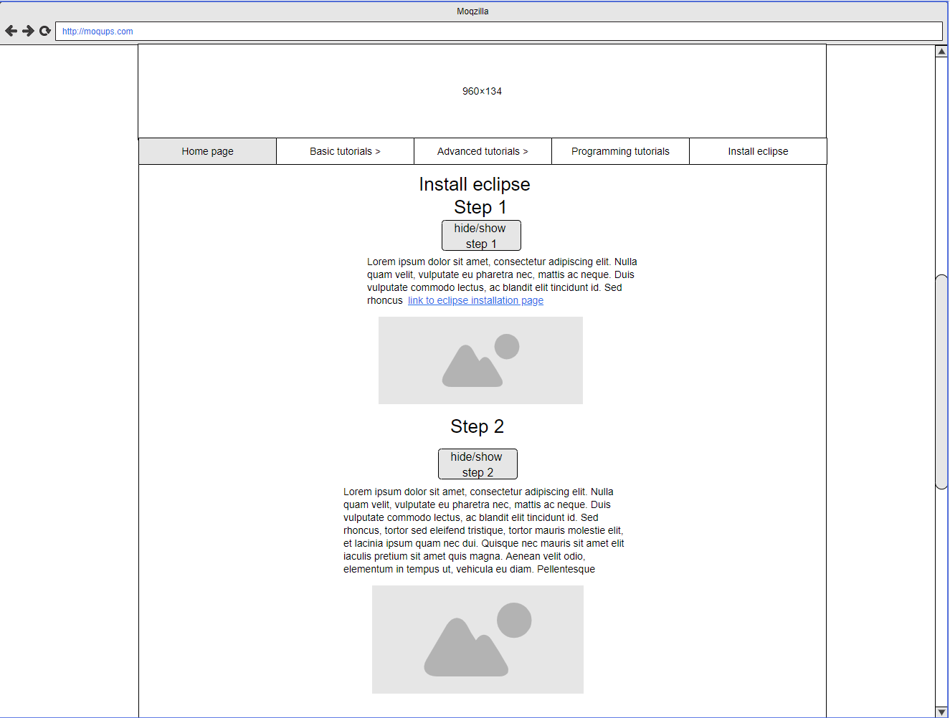

## 2.5 Scenarios

To help me identify what users will be able to do and how they will carry it out I have created a scenario for each of the personas that I have created.

### 2.5.1 Scenario 1

Andy has opened the website on google chrome to look for the tutorials he currently does not have eclipse installed on his computer.

The first thing that he sees when he opens up the website is the home page he notices the option to install eclipse on the navigation bar, he clicks the on installation guide and is brought to the tutorial on how to install eclipse which has a link to the eclipse download page once he has downloaded eclipse he follows the guide and now has eclipse installed on his computer.

He then navigates to the basic tutorial section and a drop-down menu with all of the tutorials is displayed since he has never used eclipse before, so he decides to start from the first tutorial and linearly follow all of the tutorials.

The way that he has done this is by using his computer to download eclipse once he has eclipse open, he carried out the instructions from the tutorial.

### 2.5.2 Scenario 2

Paul has opened the website on google chrome to look for the more advanced tutorials about eclipse he already has eclipse installed on his computer and has a good understanding of eclipse.

Once on the home page he hovers over the advanced tutorial section on the navigation bar, he then selects the tutorial he wants to read while reading the tutorial he also has eclipse open on his computer so that he can use the information from the tutorials on his own.

# 3 Prototype description

The content that will be included in the prototype will be the home page the installation guide and four pages for the basic tutorials these pages are creating a workspace tutorial, eclipse UI Introduction, Creating a project tutorial and the plugin installation guide.

The advanced tutorials and the Java programming tutorials will not be implemented in the prototype build. I feel that using the basic tutorial content will show the concept of how the tutorials will look and function these will then carry over to the other tutorials offered by the website at a later date.

While the prototype will not contain the proper text and media elements the like in the final version instead will contain placeholders that will be used to show how the website will look content that will be updated will be marked as so on the prototype to clearly indicate what will change.

the reason that I have decided to do this is that if I spent the time creating all of the media, I would have less time to spend on showing off more of the functionality of the website in the prototype.

The prototype will contain all of the CSS that the website will use such as the colour scheme and font styles that will be used the reason that I am including this in the prototype as it would help to show off the look and feel of the website and if there were any problems found with the chosen colour scheme that was not picked up in the design stage.

Showing it off in the prototype would help pick out the problems found another reason for including this is that it will not be time-consuming to add to the website and will greatly improve the look and feel of the prototype.

The prototype will be created for users who are using the website on a computer while the website will work on phones the layout of the site will not be created with phone users in mind the reason that I am doing this is to focus more effort in getting a good prototype for the computer version rather than working on two different versions.

The pages that will use animations for the prototype are the create project tutorial and the eclipse UI. I feel that this will help demonstrate the look and feel that they will have on different pages due to time limitations I am unable to create animations for all of the tutorials.

I would also like to get further user feedback about their opinion on how helpful the animations where before I implement them throughout the website. If positive feedback is given about the animations these will then be implements to all of the tutorials for the final build of the website.

The audio that will be used on the website will only be implemented in the hide/show buttons the reason that I am doing this is so I can get an idea of what users think of the buttons using sound and if they like it or not. If I get good user feedback from the users about using sound, I will implement sound to the navigation menus for the full website.

The prototype build of the website will be hosted locally. This will change in the final build instead users will access the website on a webserver. The reason that I am doing this is so that the prototype can be tested without needing access to the internet.

# 4 List of sources

## 4.1 JavaScript and CSS

<https://cdnjs.cloudflare.com/ajax/libs/animejs/2.0.2/anime.min.js>

This contains the JavaScript for the animation in the banner.

<https://cdnjs.cloudflare.com/ajax/libs/font-awesome/4.7.0/css/font-awesome.min.css>

this is used for the font in the navigation menu.

<https://www.w3schools.com/howto/tryit.asp?filename=tryhow_js_slideshow_auto>

I will be using this code to help implement the slide show that is used on the home page.

<https://www.w3schools.com/css/tryit.asp?filename=trycss_dropdown_navbar>

I will be using this code to implement the horizontal navigation menu.

## 4.2 Media

<https://www.youtube.com/watch?v=yT_e0RK0CDs>

This is a link to the video that will be used for the guide for installing plugins this is a place holder video that will be replaced in the full version of the website.

The images that are being used for the website have all been created by me using the snipping tool to take images of eclipse to use for the tutorials.

<https://www.zapsplat.com/>

this website was used to source the sound clips that are used for the buttons.

**Images**

The images that are being used have been created by me by taking screenshots using the snipping tool.

# 5 References

Collinge, R. (2017, 01 17). *how-to-design-for-color-blindness*. Retrieved 2019, from usabilla.com: https://usabilla.com/blog/how-to-design-for-color-blindness/

DVG. (2017, 04 26). *serif-vs-sans-serif-how-to-increase-your-websites-readability-by-more-than-50-2*. Retrieved 2019, from dvginteractive: https://www.dvginteractive.com/serif-vs-sans-serif-how-to-increase-your-websites-readability-by-more-than-50-2/

Material.io. (2019, 10 27). *Dark theme*. Retrieved from Material.io: https://material.io/design/color/dark-theme.html#